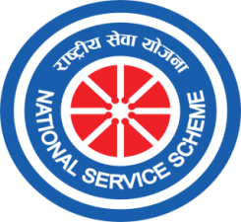
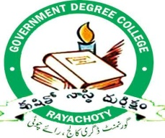
Date:
GOVERNMENT DEGREE COLLEGE, RAYACHOTY
ANNAMAYYA DIST.PIN-516269, ANDHRA PRADESH

UNIT – I
Coordinator
B.Kiran Kumar
UNIT – II
Coordinator
S.Farooq Basha

NATIONAL SERVICE SCHEME
UNIT I& II

CAMPUS CLEAN &GREEN

Volunteers of NSS unit 1&2 enthusiastically participated in the cleaning program of the college surroundings. NSS volunteers removed waste paper, fallen leaves in the college premises,.NSS volunteers, NSS Program Officers, other faculty and non teaching staff were participated in the event.
No of students attended the program= 135
Date: 09-03-2023
